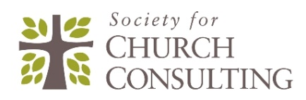
Revitalization Training Cohort Overview

Title: Levels 1-4 Training using the Revitalization Track developed in 2018
and the Fishbone Diagram Church Health Assessment White Paper

Instructor: Mark Lenz, Society President, Certified Church Consultant
Lead Consultant, Interactive Church Consulting

Cohort Description: Aspiring consultants or leaders who wish to complete Levels 1-4 training.
Training is relevant for pastors, denominational leaders, other leaders. and aspiring consultants.

Minimum Cohort: We will launch this if we have at least 3 interested in training
(Note: the alternative is recorded downloadable videos)

Registration: Email Mark to express interest first: mark@churchconsulting.org

Delivery Method: 10 Zoom teleconference Sessions, 1.5 hours each
(Cohort will decide the meeting times and dates starting approx. June 1)

Delivery Content: Lecture, Q&A discussion, 500 PowerPoint slides and other handouts
Levels 1-3: 7 Church Revitalization Tools including Fishbone Diagram of Church Health
How to Revitalize each of the 12 components of health in the Fishbone Diagram
Level 4: Understanding the Society Path to Certification
Types of Church Health Assessments and Consulting Specialties
How to Conduct a Comprehensive Church Health Assessment in 15 Weeks
How to Facilitate Strategic Ministry Planning using the Malphurs Method
How to Start a Church Consulting Practice

